The George Washington Universityshort line



**Advanced Software Paradigms (CSCI 6221.10)**

Homework Assignment #3

Date: 13 February 2024

**Submitted By:**

Abhiyan Sainju (G22510509)

**Submitted to:**

Professor Yih-Feng Hwang

Steps for execution:

1. The provided program is written in **C**. To run it, use any online C compiler, for example: [https://www.programiz.com/c-programming/online-compiler](https://www.programiz.com/c-programming/online-compiler/)/
2. Copy the code from the attached source code .txt file and paste it into the code area in the online compiler.
3. Click the “Run” button in the compiler.
4. Review the output/result displayed by the compiler, as illustrate in Figure 1.

Screenshots:

1. When the input is correct and operation is correct

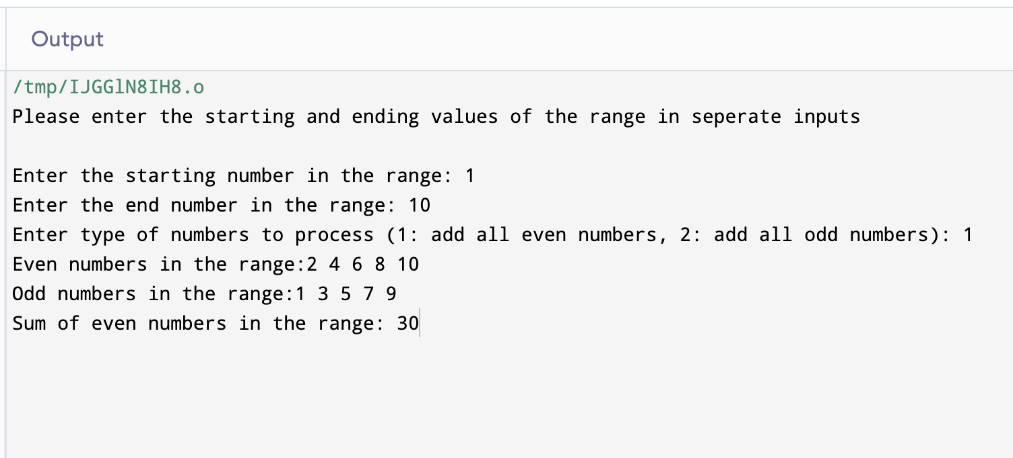

Figure 1: Result when input is correct

1. When there is error in input numbers or operation

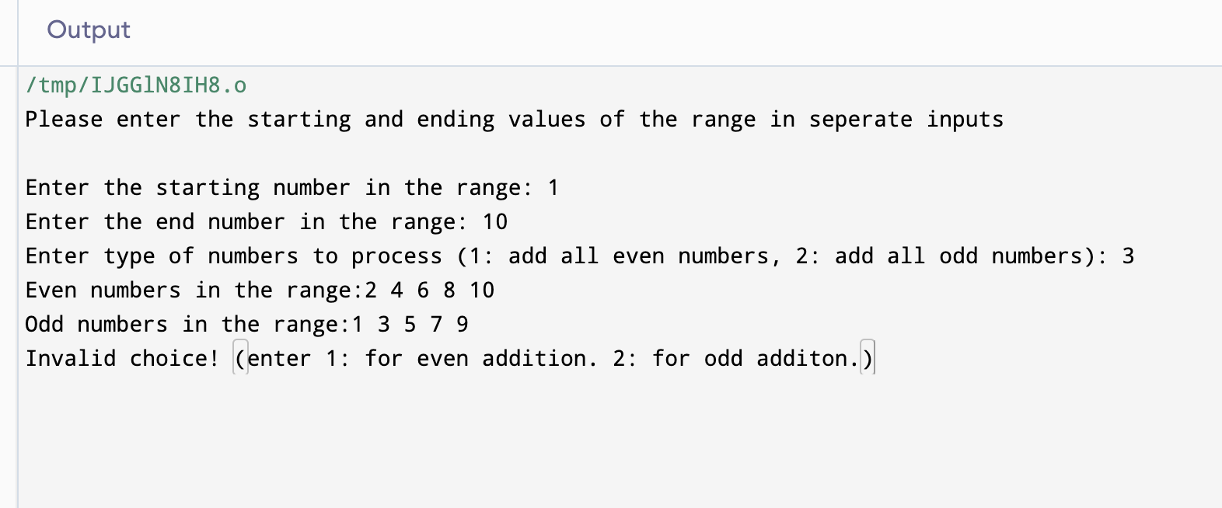

Figure 2: Result when input is incorrect